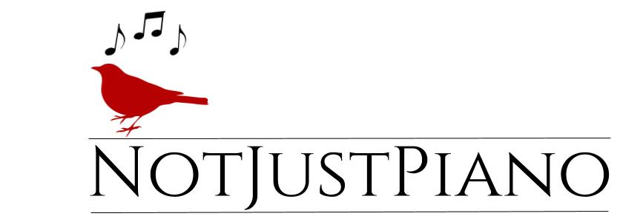
2021-2022 Policies & Procedures
Welcome to the NotJustPiano family! I look forward to seeing what God has in store for us this year.

General Information | Weekly 45 minute group piano and vocal lessons are offered. I also offer 30, or 60-minute (limited) private lessons, depending on the student’s age/level and availability. Classes are $50 a month per student. Private lessons are $40 per 30 min session.

At the Studio | Students are expected to arrive for lessons in a timely manner, with all required materials and music. Please, do not arrive more than 5 minutes before your scheduled lesson. Parents and siblings may sit at the back yard, sit quietly on the couch in the living room, wait in their vehicle in the driveway, or run errands so long as they return to pick up their student in a timely fashion. Please use caution and watch all students while outside of the house. For parents who chose to attend classes, you may be asked to wait outside if it is determined it is a hindrance or distraction to student or group progress. If you are dropping of your child please make sure you arrive on time at the end of the scheduled lesson. When you are late this interferes with any following scheduled lessons or classes.

Practice and Instrument | Private students are expected to practice daily on a well-maintained acoustic piano or weighted/semi-weighted keyboard with a pedal.

Payment
Payments are due the 1st of each month with a 5 day grace period.. Full Tuition is due whether all lessons in month are attended or not. All Payments are non-refundable with exception to teacher absence if teacher makeup is not possible. I will send out text payment reminders. I no longer accept cash. I accept check, zelle (use number 972-277-7789), cash app or venmo ( All Deanna Lariz accounts). There is a $10 dollar late fee if payment is not paid by the 5th of each month. $25 fee for all checks that are returned or un-cashable. For any returned checks, paying by check will no longer be an available option for you. The teacher reserves the right to raise fees at the beginning of each new academic year. You pay the same monthly tuition rate for both long and short months.

There is an annual non-refundable $25 registration fee per family. This must be paid to secure a slot. Parents are responsible to pay for all course materials. There are two recitals a year. A recital fee will be required.
Calendar Year
Classes/Lessons are held from Aug 2 to June 30th. . I follow the Midlothian ISD school schedule with exception to the start date. Ther are no classes/lessons the week of Thanksgiving and two weeks for Christmas break. Recitals are considered a Lesson.

Summer Months
During the summer months students are still required to practice;
Students may participate in summer camp/mini workshops. Themes for the summer camps/workshops vary each year. Camp themes may include a Music Theory Boot Camp, Musical Olympics, Music History Blast From The Past, Worship Camp, Songwriting and more. Fee to be determined.
All Classes/Lessons continue through June. Registration is due in July for the coming year.
Attendance
Due to the teacher's limited availability, absences cannot be scheduled or made up. Teacher absence makeups will be held 1st and 3rd Saturdays 11-2 pm as a group setting. If you miss a lesson for whatever reason (vacations, sickness, co-oop events, school events or testing, church events, student was tired) you forfeit that lesson. Group lessons can not be rescheduled with exception to teacher absence. If you are absent for a group lesson an option as long as there is a keyboard available, is attending another same leveled class during the week. In the event the teacher is absent for group lessons, a group make-up will be scheduled for the 1st or 3rd Saturday of the month, between 11 and 2 pm. Remember, you are paying for that slot to be held for that month. Please be courteous to me and fellow students by notifying me at least 24 hours in advance regarding any known upcoming absences. In the event that I am sick or have a family emergency, I will provide a sub or reschedule all classes. If more than 2 lessons are missed, your slot will become open to another student and may no longer be available to you. Every class missed the further behind the student becomes. Vurtual lessons for private students may be an option during their normal lesson slot. At least 2 hours advance notice is needed.

Discontinuing Lessons
Every student stops taking lessons at some point. Ideally, this decision is made thoughtfully with plenty of discussion between the teacher, parent, and student so that lessons can cease with a positive sense of closure. Also, once I reserve your paid slot for the semester, if you
pre dropout I have to financially recover that. For these reasons, as a respect for my time, I ask for a 2 week notice through email, text or phone call, prior to discontinuing lessons. I respect the parent or student’s right to end lessons at any time. However, If a student drops without notice (dropped means not returning after 2 unexcused absences) any unpaid balances must be paid, in the event, the instructor decides to reinstate enrollment. If a student does not return in any given month, without two-week notice given, for the dropped month tuition will still be charged.

Note: At teacher discretion, a student may be asked to discontinue lessons at any time if they have unpaid tuition, an excess amount of absences, unprepared lessons, disruptive behavior in class or if they show a lack of interest.
Communication
Here are some ways to stay informed regarding NotJustPiano news and events!
Studio Email: Please watch for NotJustPiano studio emails. Adjust any filters for NotJustPiano. Facebook/Instagram Page: Students and parents are welcome to join the NotJustPiano’s facebook page. I post pictures and videos from class and recitals that you can share with friends and family!
The most effective way to contact me is by text 972-277-7789. Phone calls and emails are also welcome, especially on weekdays before 3 pm. If you contact me past 3 pm or on weekends you will get a reply the next business day. Feel free to contact me with any concerns or questions you or your student might have.
Please sign/date and return this page only to the teacher in person or through email. By signing this agreement, you understand and agree to respect and abide by All of NotJustPiano policies.

- I grant NotJustPiano, the right to take photographs of me and/or my student in connection with NotJustPiano lessons, classes or events. I authorize NotJustPiano, its assigns and transferees to copyright, use and publish the same in print and/or electronically. I agree that NotJustPiano may use such photographs of me and/or my student with or without my name and for any lawful purpose, including for example such purposes as publicity, illustration, advertising, and Web content (NotJustPiano.com or Facebook.com/NotJustPiano).
- I do not grant NotJustPiano permission to use photographs of me or my student for any social media posts for purposes of publicity, illustrations, advertising or Web Content.
_____________________________________________ __________________
Parent Signature Date
NotJustPiano Studio Instrument and Accessories agreement.

NotJustPiano provides professional musical gear for students to practice on. The utmost care must be used while using this gear. Please adhere to the following guidelines in the piano studio. No liquid or food is allowed near the piano and keyboards. Do not push hard on the keyboard buttons. Do not bang on piano and keyboards. No leaning on keyboards. Do not stretch the earphones or pull on the earphone cord. When earphones are not in use, place on top of the keyboard to the side. Do not lean or rock on piano benches. Do not do anything at the piano or keyboard that can result in the instrument and its accessories being damaged.

If it is determined by the teacher that a student has mishandled any musical gear in the studio, resulting in the gear malfunctioning or being broken, the parent is responsible to financially replace the damaged gear. The student can not return to class or lessons until the gear is replaced. Thank you for your cooperation and understanding. Reimbursement fees: Keyboards $300-$400. Benches $30-$50. Keyboard stands $40-60.
________________________________________ ____________
Parent Signature Date
________________________________________ ______________
Student Signature Date

